SECTION 3. LAND USE

Land Use and Development Trends
This section provides an analysis of land use in Poland and is accompanied by a graphic representation of the Town’s overall development pattern. Such information should help in the development of a land use plan for the future that promotes orderly growth, protects rural character, makes efficient use of public facilities and services and prevents urban sprawl.

RESIDENTIAL DEVELOPMENT
As of January 2020, there were 2,791 residential dwelling units in Poland. Source: TRIO Assessment Summary by Code, Billing Amounts by Land Code. This is an increase of 486 units. Earlier, according to Census data, as of 2000 there were 2,305 residential dwelling units in Poland, compared to 1,509 units in 1980. This represents a 52 percent increase, or the addition of approximately 800 units, between 1980 and 2000.

Historically, residential land use was primarily located in the Town’s several villages and scattered throughout the rural areas of the Town. Older concentrations of residential development can be found in the Poland, East Poland, and West Poland villages. More recent development has been located along most existing roadways and scattered throughout the community. Large parcels of land in all different zones have become targeted for residential subdivision.

In 2001 the Comprehensive Land Use Code was adopted based on the Comprehensive Plan as updated in 2000. The CLUC included zoning districts and standards to direct new residential development to appropriate areas. Since 2000, most new residential structures have been located in the Village or Rural Residential Districts and a smaller amount in the Farm and Forest District. Based on this the CLUC has been successful in limiting new residential development in the Farm and Forest District. The purpose of the Farm and Forest District is to preserve the rural character of the Town.

There has been heavy seasonal residential development on several of the Town’s water bodies, including Middle and Upper Range Ponds and the eastern shore of Tripp Pond, as well as Thompson Lake. Many of the traditionally seasonal homes have been converted into year round residences. The amount of buildable lots remaining on the water bodies of Poland is quite small.

It is anticipated that over the planning period new residential development will continue to be in the Rural Residential and Village Districts.

COMMERCIAL/INDUSTRIAL DEVELOPMENT
According to the CEDC Business Database, there are 178 businesses in Poland. The list does not include a number of properties classified as commercial, including buildings leased for use as a post office, and property owned by, Fairpoint Communications and the St. Lawrence and Atlantic Railroad company. Some of the businesses might technically be considered industries, including Pike Industries, Poland Spring Corporation, and Maine Bottling Co. Other uses, such as private boys’ and girls’ camps, might technically be considered institutional uses.

Industrial type land use are located adjacent or near Route 122 including the Poland Spring Bottling Plant, Pike Industries and Old Castle Products. MB Bark is located on the Hardscrabble Road. Route 26 has attracted most of the commercial/service type businesses.

The Town has three Tax Increment Financing districts. TIF 1 is associated with the Poland Spring Bottling Plant. TIF 2, known as the Village TIF, is adjacent to TIF 1 and encompasses land along RT 26 and RT 122. The third TIF, the Downtown TIF, creates a district for development along the Route 11 and Route 26 corridors in town.

Funding from the TIF districts has been used to construct an extension of the sewer line north along RT 26 from its current terminus near the intersection of RT26 and 122 to the south end of the causeway at Middle Range Pond. Part of this project included bringing three phase power north on RT 26 to the south end of the causeway as well
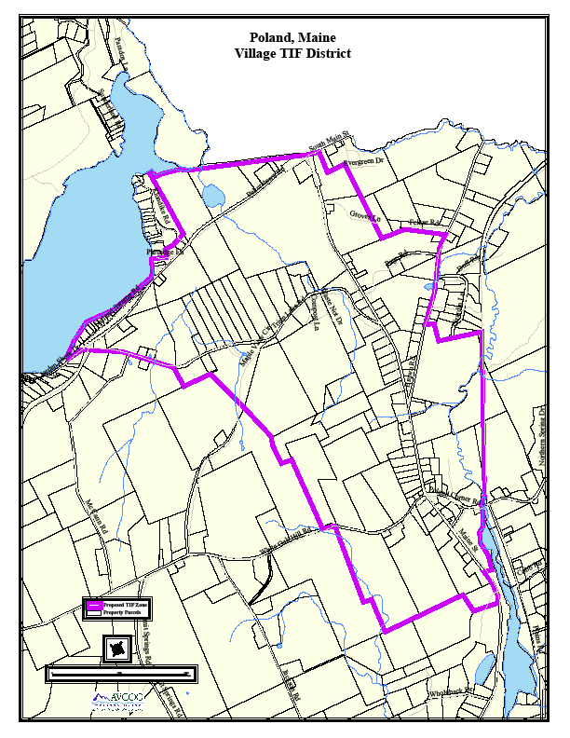

MAPS WOULD GO IN THIS SECTION

TIF 1
TIF 2
DTV
PERHAPS A LARGE MAP OF THE TOWN SHOWING ZONES

A Pine Tree Zone also has been created between the Hardscrabble Road and the St. Lawrence Rail Line.

The town of Poland has also formed a Community and Economic Development Committee. The charge of the committee was to attract and site business that would be compatible with the rural nature of the town while expanding the tax base to slow the rate of increase of taxation on residential property owners. That committee was instrumental in recommending infrastructure projects to be funded with TIF funds, specifically, the extension of the sewer line north on RT 26.

PUBLICLY OWNED AND TAX-EXEMPT LAND
Much of this property is concentrated along the Route 26/Plains Road corridor and in the areas south and west of Tripp Pond. There have been some additions in recent years. Most notably the Heart of Poland conservation area.

The single largest tax-exempt parcel is Range Pond State Park (actually two separate parcels) at 740 acres. The Maine Forest Service owns a parcel on the Little Androscoggin River, and the Department of Inland Fisheries and Wildlife owns three small parcels on Upper Range Pond.

Altogether, the Town owns 44 parcels of land, which collectively amount to 566.87 acres. Municipal government buildings are on seven parcels totaling approximately 48 acres, the remaining parcels are land only totaling roughly 518.87 acres. The following table shows the location of the town owned properties.

TOWN OWNED PROPERTY
Map-Lot | Street Address | Acreage | Description
2A-11 | Spring Water Road | 1.03 | Land only
2A-11A | Spring Water Road | 0.37 | Land only
2A-13-B1 | West Crestwood Dr. | 13.5 | Land only
4-14A | Hardscrabble Rd | 2.0 | Land only
5-33A | Off Schellinger Road | 0.00 | Building only/Estes Bog
6-18A | Conner Lane | 8.5 | Town Beach/ Lower Range
6-18B | 70 Connor Lane | 2.75 | Camp Connor
7-14D | Bailey Hill Road | 13.0 | Land only
9-6A | Off Black Cat Mountain | 3.40 | Land only
9-10A | Off Black Cat Mountain | 18.47 | Land only
9-31 | North Raymond Road | 116 | Land only
9-40 | Bragdon Hill | 43.8 | Land only
9-41 | Bragdon Hill | 12.0 | Land only
9-42 | Bragdon Hill | 45.0 | Land only
10-26 | Off Maine St | 10.0 | Land behind Town Office
10-28 | 33 Poland Corner Road | 22.5 | Fire Rescue Building
10-28-1 | Poland Corner Road | 0 | Building only/Waterhouse Brook Dam
10-54 | Maine St | 19.0 | Supt/Bus Dispatch
10-94 | Off Estes Way | 9.5 | Land only
11-2 | Poland Corner Road | 21.75 | Land only/ Abuts Pine Grove Cemetery
11-4-1 | Poland Corner Road | 6.0 | Railroad
11-4A | Poland Corner Road | 2.5 | Land only/ Abuts Railroad
11-67 | Everett Road | 0.2 | Land only
15-1-2 | Hilt Hollow Road | 1.85 | Heart of Poland Conservation
15-1-3 | Hilt Hollow Road | 2.03 | Heart of Poland Conservation
15-1-4 | Hilt Hollow Road | 2.76 | Heart of Poland Conservation
15-1-5 | Hilt Hollow Road | 3.95 | Heart of Poland Conservation
15-1-6 | Hilt Hollow Road | 2.25 | Heart of Poland Conservation
15-1B | 12 Tripp Lake Road | 15.0 | Transfer Station
15-1J | Tripp Lake Camp Road | 33.15 | Land only
15-6A | Maine St | 60.3 | Land only after School Split
15-26-D1 | Felker Road | 10.0 | Land only
15-35E | Off Brown Road | 8.5 | Land only
17-41 | Herrick Valley Road | 15.0 | Gravel Pit
17-47 | Off Old Tiger Hill Rd | 48.1 | Land only
17-47A | Off Tiger Hill Road | 18.5 | Land only
28-6 | Bakerstown Rd | 1.0 | Town Beach/ Tripp Lake
39-6 | 30 Poland Corner Road | 2.65 | Public Works
40-2 | 1211 Maine St | 1.47 | Library
40-3 | 1217 Maine St | 1.38 | Land only between Library & Town Office
40-3A | 1219 Maine St | 2.33 | Police Substation and Recreation
40-4 | 1231 Maine St | 1.18 | Town Office/ Old Schoolhouse
40-13A | Maine Street | 3.73 | Land only after School Split
45-116 | Birch Drive | 0.22 | Common Beach off Birch Dr
Source: TRIO 2021

FOREST LANDS
Forest Management is an important part of Poland’s economy. There are a number of significant forest areas in the community. Many of these areas are currently protected by the Town’s farm and forest zone, which requires a minimum lot size of 5 acres.

Summary of Timber Harvest Information for the town of: |  |  |  |  |  | Poland
YEAR | Selection harvest, acres | Shelterwood harvest, acres | Clearcut harvest, acres | Total Harvest, acres | Change of land use, acres | Number of active Notifications
1991 | 136 | 0 | 0 | 136 | 0 | 5
1992 | 152 | 0 | 0 | 152 | 0 | 7
1993 | 421 | 10 | 50 | 481 | 10 | 12
1994 | 253 | 45 | 2 | 300 | 0 | 12
1995 | 383 | 3 | 3 | 389 | 2 | 20
1996 | 912 | 27 | 36 | 975 | 11 | 16
1997 | 274 | 25 | 2 | 301 | 6 | 14
1998 | 395 | 8 | 70 | 473 | 0 | 23
1999 | 512 | 13 | 60 | 585 | 133 | 35
2000 | 273 | 34 | 0 | 297 | 82 | 34
2001 | 249 | 50 | 15 | 314 | 20 | 29
2002 | 162 | 30 | 0 | 192 | 17 | 21
2003 | 118 | 0 | 0 | 118 | 35 | 13
2004 | 426 | 50 | 25 | 501 | 110 | 31
2005 | 478 | 20 | 14 | 512 | 5 | 27
2006 | 902 | 33 | 0 | 935 | 4 | 25
2007 | 639 | 68 | 0 | 707 | 39 | 29
2008 | 475 | 20 | 10 | 505 | 47 | 35
2009 | 415 | 85 | 5 | 505 | 133 | 32
2010 | 677 | 13 | 0 | 690 | 12 | 34
2011 | 441 | 16 | 10 | 467 | 20 | 26
2012 | 328 | 8 | 10 | 346 | 14 | 29
2013 | 341.5 | 155 | 0 | 496.5 | 2 | 29
2014 | 486.9 | 107 | 0 | 593.9 | 0 | 33
2015 | 759 | 4.5 | 7 | 770.5 | 23 | 30
2016 | 482 | 125 | 0 | 607 | 28 | 18
2017 | 300 | 221 | 0 | 521 | 6 | 20
2018 | 296 | 0 | 0 | 296 | 31 | 19
Total | 11686.4 | 1170.5 | 319 | 13165.9 | 790 | 658
Average | 417 | 42 | 11 | 470 | 28 | 24
Data compiled from Confidential Year End Landowner Reports to Maine Forest Service.
Department of Agriculture, Conservation and Forestry - Maine Forest Service
We help you make informed decisions about Maine's forests

A number of Poland’s landowners have placed their forestlands in Tree Growth. The Tree Growth Law allows for the assessment of forestland based on current use rather than market value as long as the land is managed for timber production and remains as forest. In April 2020, there were 4,407.06 acres, or 93 parcels, listed in Tree Growth. In April 2006, there were 3,649 acres, or 72 parcels, listed in Tree Growth. Source: Maine State Valuation 2020.

The Town of Poland is actively involved in managing the forestry resources of the Town Farm and a number of Town-owned woodlots. In 1983, the New England Forestry Foundation prepared for the Town a Woodland Examination Report for the Town’s woodlots. The Report contained recommendations for timber cutting. Since the report, the town has conducted timber harvests under the recommendation of the town forester.

Town Timber Sales, 1996-2007
Date | Lot | Volume | Gross Sales
October, 1996 | Hewey | 56300 Bdft + 55 Cords | $11,387.50
October, 1996 | Mingo | 120,000 Bdft + 170 Cords | $19,004.00
October, 1997 | Town Farm East | 41,000 Bdft + 123 Cords | $15,000.00
July, 1999 | Transfer Station | 49,250 Bdft + 60 Cords | $10,750.00
December, 2002 | Town Farm West | 115,650 Bdft + 123 Cords | $26,600.00
2007 | Mingo Lots | 224,500 Bdf + 500 Cords | $48,560.00
2009 | Transfer Station | 27,500 BBdft + 17 Cords | $6,300.00
2010 | Town Forest East | 64,000 Bdft + 130 Cords | $18,210.00
2014 | Hewey | 61,800 Bdft + 123 Cords | $14,249.00
2020 | Mingo | 72,800 Bdft + 677 Cords | $15,629.00
2020 | Town Forest West | 31,000 Bdft + 677 Cords | $5,450.00
2020 | Jackson | 41,335 Bdft + 620 Cords | $9,624.00
Totals |  | 1,129,535 Bdft + 2,134 Cords | $239,694.50
Prepared By Fred A Huntress Jr., Town Forester

AGRICULTURE
As of April 2020, there were 19 parcels of land in Poland devoted to agriculture for 347 acres. This is a change from April 2006 where 21 parcels of land in Poland devoted to agriculture for a combined acreage of 328 acres. Of the above values for April 2020, 4 parcels totaling 146 acres were classified as under the Farm and Open Space Tax law as cropland, orchard land or pastureland. An additional 415.5 acres were classified as farm woodlands. This contrasts with April 2006 data showing 13 parcels totaling 312 acres were classified as under the Farm and Open Space Tax law as crop land, orchard land or pasture land. An additional 366 acres were classified as farm woodlands. This classification is analogous to the tree growth program but deals with agricultural land. It assesses the lands current use as farm and open space rather than market value. Most of the agriculture in the Town is located in East Poland, particularly along the Little Androscoggin River, and Hardscrabble Road. Also on Shaker Hill, Empire Road, and Range Hill. Source: Maine State Valuation 2020.

LAND USE ORDINANCES
The Town of Poland Comprehensive Land Use Code, Chapter 5 Land Zoning Standards, contains a description of land uses and locations for that use approved within the Town of Poland. Additionally, an interactive map showing details of Land Zoning Standards can be found on the GIS portion of the town web site at https://www.polandtownoffice.org/.

