INVENTORY
- Traffic light at the Route 122/26 intersection
- Encourage/attract public transport options
- Continue to support hiking trails, and ATV/Snowmobile trails

Introduction
The location of transportation routes is important to Poland’s and the region's development patterns and overall economic well-being. Poland’s transportation system consists of state, local and private roads, bridges, as well as bicycle, pedestrian, snowmobile, ATV, transit, and rail systems. This multimodal system is extremely important to existing and future development characteristics, both at the local and regional levels.

Highway Classifications
The Maine Department of Transportation (MaineDOT) has classified highways based on functions within Poland as Arterial, Collector or Local. There are 14.15 miles of Arterial highways in Poland. Poland has 17.53 miles of Collector highway, and 55.63 miles of Local roads. Brief definitions of the highway functional classifications, as used by MaineDOT, are as follows:

Arterial Highways: The most important travel routes in the state. These roads carry high speed, long distance traffic and attract a significant amount of federal funding. The state is responsible for road repair, resurfacing and winter maintenance on Arterial highways. Mechanic Falls Road (Route 11/121), Bakerstown Road (Route 11), and Maine Street (Route 26) are Arterial Highways.

Collector Highways: These routes collect and distribute traffic from and to the arterial routes serving places of lower population densities, and they are somewhat removed from main travel routes. Spring Water Road (Route 122) is the only Major Collector Highway in Poland. Megquier Hill Road and White Oak Hill Road are Minor Collector Highways. Typically the State is responsible for road repair and resurfacing on all state roads. However, the state is only responsible for the winter maintenance responsibility of state roads in nonurban areas.

Local Roads: Local roads are designed primarily to serve adjacent land areas and usually carry low volumes of traffic. The town is responsible for both summer and winter maintenance of local roads.

Public Road Conditions
The following table shows the road inventory data provided by the town of Poland (roads highlighted in yellow are private roads):

Town of Poland Road Survey
ROAD NAMES | LOCATION
ABRAMS LANE | OFF JOHNSON HILL ROAD
AGASSIZ VILLAGE LANE | OFF JOHNSON HILL ROAD
AGGREGATE ROAD | TOWN GARAGE TO MAINE STREET
ALEXANDER LANE | OFF MAPLE LANE
AMANDA CIRCLE | OFF SPRING WATER ROAD
AMVET ROAD | OFF CLEVE TRIPP ROAD
AMY STREET | BROOKDALE VILLLAGE
ANDREW STREET | BROOKDALE VILLLAGE
ANN STREET | BROOKDALE VILLLAGE
APPLE BLOSSOM DRIVE | OFF POLAND CRNR ROAD
ARTHUR'S WAY | OFF LEWISTON JCT. ROAD
ASH DRIVE | COUNTRY VILLAGE TRLR PK
ASPEN WAY | OFF WEST CRESTWOOD
AUCTION DRIVE | OFF PLAINS ROAD
AUGUST STREET | BROOKDALE VILLAGE
AUTUMN DRIVE | OFF CARPENTER ROAD
BACKWOOD DRIVE | OFF EMPIRE ROAD
BAILEY HILL ROAD | OFF HARRIS HILL ROAD/PLAINS ROAD
BAKERSTOWN RD | FIVE CORNERS TO CASCO T.L. (RTE 11)
BALLFIELD ROAD | OFF FRONT AVENUE-EMPIRE GROVE
BARK MULCH DRIVE | OFF HARDSCRABBLE ROAD
BASS COVE LANE | OFF HEATH ROAD
BEECHNUT LANE | OFF AUTUMN DRIVE (CARPENTER ROAD end)
BELANGER DRIVE | OFF EVERETT ROAD
BELL LANE | OFF MEGQUIER HILL ROAD
BERRY COURT | COUNTRY VILLAGE TRLR PK
BILLFRED WAY | OFF HARRICK VALLEY ROAD
BIRCH DRIVE | OFF WESTVIEW DRIVE
BIRCHWOOD LANE | OFF MAINE STREET (RT 26)
BISHOP ROAD | OFF SPRING WATER ROAD
BLACK DUCK LANE | OFF CLEVE TRIPP ROAD
BLACK ISLAND ROAD | OFF KOHUT RD – OXFORD
BLACKBERRY LANE | OFF OSPREY COVE LANE
BLACKCAT MOUNTAIN ROAD | OFF CASSIE LANE
BLUEBIRD DRIVE | OFF DEERFIELD ROAD
BOIS LANE | OFF CLEVE TRIPP ROAD
BOLDUC LANE | OFF MEGQUIRE HILL ROAD
BOOT HILL ROAD | OFF MAPLE VIEW CIRCLE
BRAGDON HILL ROAD | OFF SCHELLINGER ROAD
BRITTANYS WAY | OFF HARDSCRABBLE ROAD
BROADWAY CIRCLE | OFF FRONT AVENUE - EMPIRE GROVE
BROOK DRIVE | BROOKDALE VILLAGE
BROWN ROAD | OFF MAINE STREET (RT 26)
BUNTING LANE | OFF MEGQUIRE HILL ROAD
CAMP FERNWOOD LANE | OFF MEGQUIRE HILL ROAD
CARDINAL LANE | OFF WALKER POINT ROAD
CARPENTER ROAD | OFF MAINE STREET (RTE 26)
CASSIE LANE | OFF NORTH RAYMOND ROAD
CEDAR MILLS ROAD | OFF BELANGER DRIVE
CEMETERY ROAD | POLAND SPRING COMPLEX
CHABOT DRIVE | OFF MECHANIC FALLS ROAD (was Pearl Place)
CHERRY DRIVE | CNTRY VIL TRLR PK
CHESTNUT DRIVE | CNTRY VIL TRLR PK
CHICKADEE LANE | OFF SCHELLINGER ROAD
CIMINO DRIVE | OFF EMPIRE RD & SPRING WATER Rd Intersection
CLEVE TRIPP ROAD | OFF SCHELLINGER ROAD
CLIFF LANE | OFF RUSSELL ROAD
COBB BROOK LANE | OFF BAILEY HILL ROAD
COBB ROAD | OFF PLAINS ROAD
COBBLE KNOLL ROAD | OFF SPRING WATER ROAD (RTE 122)
COLBATH ROAD | OFF RANGE HILL ROAD
COMPOST LANE | TRANSFER STATION
CONNOR LANE | OFF MAINE STREET (RTE 26)
COTE DRIVE | BETWEEN DAVIS BROOK DRIVE & AMY DRIVE
COTTAGE WAY | OFF PRESERVATION WAY
COVE VIEW PLACE | OFF ISLAND COVE LANE
CRANBERRY LANE | OFF AUTUMN DRIVE NEAR CARPENTER ROAD
DALE STREET | BROOKDALE VILLAGE
DAVIS BROOK DRIVE | BROOKDALE VILLAGE
DEER RUN LANE | OFF JOHNSON HILL ROAD (OLD FL 27)
DEERFIELD ROAD | ACCESS FROM N. GLOUCESTER-COLBATH ROAD
DOE LANE | OFF AUTUMN DRIVE NEAR CARPENTER ROAD
DOTEN LANE | OFF EMPIRE ROAD
DOWNY LANE | OFF SPRING WATER ROAD/RANGE ROAD
DUFF ROAD | OFF GIRARDIN LANE
DUNN ROAD | OFF EMPIRE ROAD
EAST CRESTWOOD | OFF SPRING WATER ROAD
EAST RECORD ROAD | OFF EMPIRE ROAD (RECORD ROAD)
EASY STREET | OFF SCHELLINGER ROAD
ECHO COVE LANE | OFF CLEVE TRIPP ROAD
EDWARDS ROAD | OFF JOHNSON HILL ROAD
ELM STREET EXTENSION | OFF POLAND CORNER ROAD
EMPIRE ROAD | OFF SPRINGWATER ROAD
ESTES WAY | OFF SUMMIT SPRING ROAD
EVERETT ROAD | OFF HARRIS HILL ROAD
EVERGREEN DRIVE | POLAND TRLR PARK
FELKER ROAD | OFF BROWN ROAD
FERNALD ROAD | OFF MEGQUIRE HILL ROAD
FIDDLEHEAD LANE | OFF AUTUMN DR (CARPENTER ROAD end)
FIELDSTONE ROAD | OFF MEGQUIRE HILL ROAD
FIRST AVENUE | OFF WESTVEW DRIVE
FLORENCE LANE | OFF JOHNSON HILL ROAD
FLYNT DRIVE | OFF POLAND CORNER ROAD
FOREST DRIVE | OFF DAVIS BROOK DRIVE (Brookdale II)
FOSTER ROAD | FROM LEWISTON JCT. RD TO HOTEL RD IN AUBURN
FOURTH AVENUE | OFF BIRCH DRIVE
FOX RUN ROAD | OFF LANE ROAD
FRANK WAY | OFF LANE ROAD
FRONT AVENUE | EMPIRE GROVE CMPGND
GAGNE LANE | OFF BAILEY HILL ROAD
GARLAND SWAMP ROAD | OFF BAKERSTOWN ROAD (RTE 11)
GARRETTS LANE | OFF BAKERSTOWN ROAD (RTE 11)
GIRARDIN LANE | OFF BROWN ROAD
GLEN LANE | OFF CLEVE TRIPP ROAD
GOSS WAY | OFF HARRIS HILL ROAD
GREENWOOD DRIVE | OFF HINES ROAD
GROVES LANE | OFF MAINE STREET (RTE 26)
HACKETT MILLS ROAD | OFF HARRIS HILL ROAD
HALE ROAD | OFF TENNEY HILL ROAD, RAYMOND, ME
HALF MOON LANE | OFF MEGQUIRE HILL ROAD
HARDSCRABBLE ROAD | OFF EMPIRE ROAD
HARRIS HILL ROAD | OFF POLAND CORNER ROAD
HART'S LANE | OFF LANE ROAD
HARVEST DRIVE | OFF AUTUMN DRIVE
HASKELL LANE | OFF BOLDUC LANE
HEATH ROAD | JOHNSON HILL ROAD TO CASCO T.L
HEMLOCK LANE | OFF WESTVIEW DRIVE
HERRICK VALLY ROAD | FROM WINTERBROOK RD TO MEGQUIRE HILL RD
HICKORY WAY | OFF EMPIRE ROAD
HIDEAWAY ROAD | OFF EVERETT ROAD
HIGH VIEW DRIVE | OFF MAINE STREET (RTE 26)
HILL LANE | OFF NORTH RAYMOND ROAD
HILL VALLEY ROAD | OFF TIGER HILL ROAD
HILT HOLLOW | OFF MAINE STREET
HINES ROAD | OFF MAINE STREET NEAR CARPENTER ROAD
HOLMES DRIVE | OFF HARRIS HILL ROAD
HOPE SPRINGS ROAD | OFF BAILEY HILL ROAD
HORSE VIEW LANE | OFF HART'S LANE
HOTHAM LANE | OFF HARRIS HILL ROAD
HUNT ROAD | OFF POLAND CORNER ROAD
IRIS DRIVE | OFF HINES ROAD
ISLAND COVE LANE | OFF MEGQUIRE HILL ROAD
JACKSON ROAD | OFF WHITE OAK HILL ROAD
JESSICA WAY | OFF BAKERSTOWN & NORTH RAYMOND ROADS
JOHNSON HILL ROAD | OFF MEGQUIRE HILL ROAD
JORDAN SHORE DRIVE | OLD RTE 11 BY TRIPP LAKE ROAD
JOSH'S WAY | OFF DAVIS BROOK DRIVE (Brookdale II)
JULIE STREET | BROOKDALE VILLAGE
KEYSTONE SPRING ROAD | OFF EMPIRE ROAD
KING AVE | OFF BROADWAY CR. EMPIRE GROVE
KLONDIKE ROAD | OFF BAKERSTOWN ROAD (RTE 11)
KNOLL ROAD | OFF JOHNSON HILL ROAD
LAFRINEA LANE | OFF CARPENTER ROAD
LAKE SHORE DRIVE | OFF MAINE STREET (RTE 26)
LAKEN LEDGE LANE | OFF MEGQUIER HILL ROAD
LAKEWOOD LANE | OFF MEGQUIRE HILL ROAD
LANE ROAD | OFF HACKETT MILLS ROAD
LARCH DRIVE | OFF FERNALD ROAD
LEGENDRE LANE | OFF MEGQUIRE HILL ROAD
LENAHANS LANE | OFF CLEVE TRIPP ROAD
LEVINE ROAD | OFF HARDSCRABBLE ROAD
LEWISTON JUNCTION ROAD | OFF EMPIRE ROAD
LINDEN LANE | OFF RANGE HILL ROAD
LITTLE HILL LANE | OFF ABRAMS LANE
LOON POINT LANE | OFF ABARAMS LANE
LUCY'S DRIVE | OFF JOHNSON HILL ROAD
LUNT LANE | OFF MEGQUIRE HILL ROAD
MAINE STREET | FORMERLY RTE 26
MAPLE LANE | OFF HARRIS HILL ROAD
MAPLE VIEW CIRCLE | OFF TRIPP LAKE ROAD
MARJORIE LANE | OFF FERNALD ROAD
MARK STREET | BROOKDALE VILLAGE
MAX PINE LANE | OFF RANGE HILL ROAD
McCANN ROAD | OFF WHITE OAK HILL ROAD
MCEACHERN DRIVE | OFF ROSSMORE LANE IN NEW GLOUCESTER, ME
MCINTOSH LANE | OFF EDWARDS ROAD
MECHANIC FALLS ROAD | FORMERLY RTES 121 & 11
MEGQUIER HILL ROAD | OFF BAKERSTOWN ROAD (RTE 11)
MICHAL'S LANE | OFF MEGQUIER HILL ROAD
MILLER DRIVE | OFF BROADWAY CIRCLE - EMPIRE GROVE
MOOSE TRAIL LANE | OFF SCHELLINGER ROAD
MOSS DRIVE | OFF HINES ROAD
MOUNTAIN VIEW DRIVE | OFF DEERFIELD ROAD
NARROW WAY ROAD | OFF HARRIS HILL ROAD
NASH LANE | OFF OSPREY COVE LANE, OFF FL 32
NORTH RAYMOND ROAD | OFF BAKERSTOWN ROAD (RTE 11)
NORTHERN SPRING DRIVE | OFF POLAND CRNR ROAD, FLYNTT TRLR PK
NUMBER 5 ROAD | OFF COLBATH ROAD
NUTHATCH LANE | OFF SCHELLINGER ROAD
OAK LANE | OFF KLONDIKE ROAD
OAKRIDGE DRIVE | OFF BIRCHWOOD LANE
OLD BLACKCAT MOUNTAIN ROAD | OFF NORTH RAYMOND ROAD
OLD COUNTY ROAD | OFF HERRICK VALLEY ROAD
OLD PLAINS ROAD | OFF PLAINS ROAD
OLD TIGER HILL ROAD | OFF HERRICK VALLEY ROAD
OLD WOODS ROAD | OFF FRONT AVENUE, EMPIRE GROVE
ORCHARD ROAD | OFF HIDEAWAY ROAD
ORIOLE DRIVE | OFF HINES ROAD
OSPREY COVE LANE | OFF TUCKER LANE
OTTER LANE | OFF NORTH RAYMOND ROAD
OUTLET ROAD | OFF MAINE STREET
PAGE ROAD | BETWEEN BROWN ROAD & MAINE STREET (RTE 26)
PALOMA DR | OFF HARRIS HILL ROAD
PARADOX LANE | OFF HERRICK VALLEY ROAD
PARK AVENUE | OFF FRONT AVENUE, EMPIRE GROVE
PARSON'S POINT ROAD | IN CASCO OFF HEATH ROAD
PARSONS WAY | OFF FRONT AVENUE, EMPIRE GROVE
PARTRIDGE LANE | OFF BAKERSTOWN ROAD (RTE 11)
PENNEY ROAD | OFF KLONDIKE ROAD
PERKINS ROAD | OFF SAUNDERS ROAD
PHILIP WAY | OFF WHALEBACK DRIVE (DUNN'S GRAVEL PIT)
PINE AVENUE | OFF BROADWAY CIRCLE, EMPIRE GROVE
PLAINS ROAD | OFF POLAND CORNER ROAD
PLEASANT VALLEY CIRCLE | OFF MOUNTAIN VIEW DRIVE
PLUMMER ROAD | OFF MEGQUIRE ROAD, FRMLY E RUSSELL
POLAND CORNER ROAD | OFF MAINE STREET (RTE 26)
POLAND PLACE | BETWEEN BROWN ROAD & GIRARDIN LANE
POLAND SPRING DRIVE | OFF SPRING WATER ROAD & EMPIRE ROAD
POND LANE | OFF MEGQUIRE HILL ROAD
POPLAR DRIVE | COUNTRY VILLAGE TRLR PK
POTASH LANE | OFF RUSSELL ROAD
PRESERVATION WAY | POLAND SPRING COMPLEX
PROULX LANE | OFF MEGQUIRE HILL ROAD
PULSIFER ROAD | OFF BAILEY HILL ROAD
PUMPKIN LANE | OFF AUTUMN LANE
QUARRY ROAD | OFF MAINE STREET
RANGE HILL ROAD | OFF MAINE STREET (RTE 26)
RANGE ROAD | OFF SPRINGWATER ROAD
RAVEN DRIVE | OFF AUTUMN DRIVE
RAYS WAY | OFF HEATH ROAD, FRMRLY MAYBERRY
REDUCE IT DRIVE | TRANSFER STATION
RICKER ROAD | OFF MAINE STREET (RTE 26)
ROBBINS WAY | POLAND SPRING COMPLEX
ROBERT'S DRIVE | OFF POLAND CORNER ROAD
ROCKWOOD LANE | OFF MEGQUIRE HILL ROAD
ROLLY'S CAMP ROAD | OFF NUMBER 5 ROAD
ROSEWOOD LANE | OFF N SPRING DRIVE
RUSSELL ROAD | OFF JOHNSON HILL ROAD
SANDERSON ROAD | OFF SAUNDERS ROAD
SANDY LANE | OFF MECHANIC FALLS ROAD (RTE 121)
SAUNDERS ROAD | OFF PLAINS ROAD
SAWYER ROAD | OFF COBB ROAD
SCHELLINGER ROAD | OFF MAINE STREET (RT 26)
SCHWABE LANE | OFF RANGE HILL ROAD
SECOND AVENUE | OFF WESTVIEW DRIVE
SERENITY COVE LANE | OFF MEGQUIRE HILL ROAD
SHAKER ROAD | FROM OUTLET ROAD TO NEW GLOUCESTER T.L.
SHANNON LANE | OFF N RAYMOND ROAD
SIMPLICITY WAY | OFF MAINE STREET
SOUTH MAIN STREET | McFALLS T.L TO 5 CORNERS (RT 11)
SPRING WATER ROAD | FORMERLY RTE 122
SPRUCE DRIVE | OFF BLACK DUCK LANE
STARRY NIGHT DRIVE | OFF MAINE STREET
STATE PARK ROAD | OFF EMPIRE ROAD
STONES LANE | OFF MEGQUIRE HILL ROAD
STONEWALL DRIVE | OFF LEWISTON JCT. ROAD
STORM COVE LANE | OFF RUSSELL ROAD
STRAWBERRY LANE | OFF AUTUMN DRIVE (HINES ROAD end)
STROUT ROAD | OFF WHITE OAK HILL ROAD
SUMMIT SPRINGS ROAD | OFF WHITE OAK HILL ROAD
SUNDERLAND ROAD | OFF HERRICK VALLEY ROAD
SUNSET COVE LANE | OFF MEGQUIRE HILL ROAD
TAMERACK WAY | OFF JESSICA WAY
TAYLOR BROOK DRIVE | OFF BAKERSTOWN ROAD
TENNIS ROAD | OFF PRESERVATION WAY
THIRD AVENUE | OFF BIRCH DRIVE
THREE (3 R BLVD) | TRANSFER STATION
TIBBETTS WAY | OFF BUNTING LANE
TIGER HILL ROAD | OFF HERRICK VALLEY ROAD
TIMBER LANE | OFF MOUNTAIN VIEW DRIVE
TORREY ROAD | OFF DUNN ROAD/EMPIRE ROAD
TRIPP LAKE CAMP ROAD | OFF HERRICK VALLEY ROAD
TRIPP LAKE ROAD | OFF MAINE STREET (RTE 26)
TRUMAN WAY | OFF SCHELLINGER ROAD
TUCKER LANE | OFF N RAYMOND ROAD
UNDERWOOD DRIVE | OFF WEDGEWOOD CIRCLE
UPPER RANGE DRIVE | OFF WATSON ROAD
VERRILL ROAD | OFF SPRING WATER ROAD (RTE 122)
VILLAGE STREET | BROOKDALE VILLAGE
WALKER POINT ROAD | OFF SCHELLINGER ROAD
WALNUT STREET | OFF EVERGREEN DRIVE, POLAND TRLR PK
WASTE NOT DRIVE | TRANSFER STATION
WATERHOUSE ROAD | OFF KLONDIKE ROAD
WATSON ROAD | OFF CLEVE TRIPP ROAD
WEBSTER'S WAY | OFF BAILEY HILL ROAD
WEDGEWOOD CIRCLE | OFF AUTUMN DRIVE
WELSH LANE | OFF POLAND CORNER ROAD AND NORTHERN SPRINGS
WEST CRESTWOOD | OFF SPRING WATER ROAD (RTE 122)
WEST RECORD ROAD | OFF HARRIS HILL ROAD (FRMRLY RCRD ROAD)
WEST SHORE DRIVE | OFF NUTHATCH LANE
WESTVIEW DRIVE | OFF MAINE STREET (RTE 26)
WHALEBACK DRIVE | OFF MAINE SREET (RTE 26) DUNN'S PIT
WHISPERING PINE DRIVE | OFF JESSICA WAY
WHITE OAK HILL ROAD | OFF MAINE STREET (RTE 26)
WILD TURKEY WAY | OFF NORTH RAYMOND ROAD
WILLOW LANE | OFF JOHNSON HILL ROAD
WINDSOR PLACE | OFF SUNDERLAND ROAD
WINTERGREEN DRIVE | OFF WEDGEWOOD CIRCLE
WOODBERRY LANE | OFF CHICKADEE LANE
WOODLAND SHORE DRIVE | OFF BIRCH DRIVE
WORTHLEY POND ROAD | OFF SPRING WATER ROAD
YOUNG LANE | OFF JACKSON ROAD

Examination of local highway conditions is important for several reasons. Road conditions can help direct future development and suggest the need for capital expenditures for reconstruction. Poland uses the Road Surface Management System (RSMS) to inventory and determine the physical condition of local roads. The following tables show the RSMS public road inventory data for Poland:

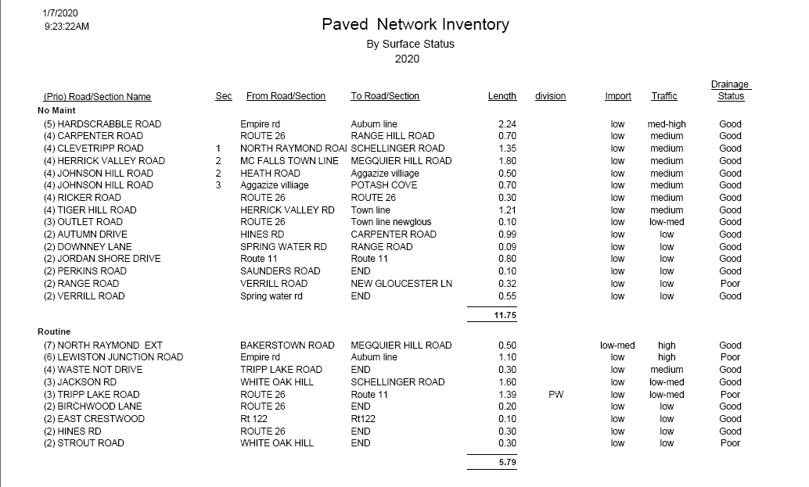

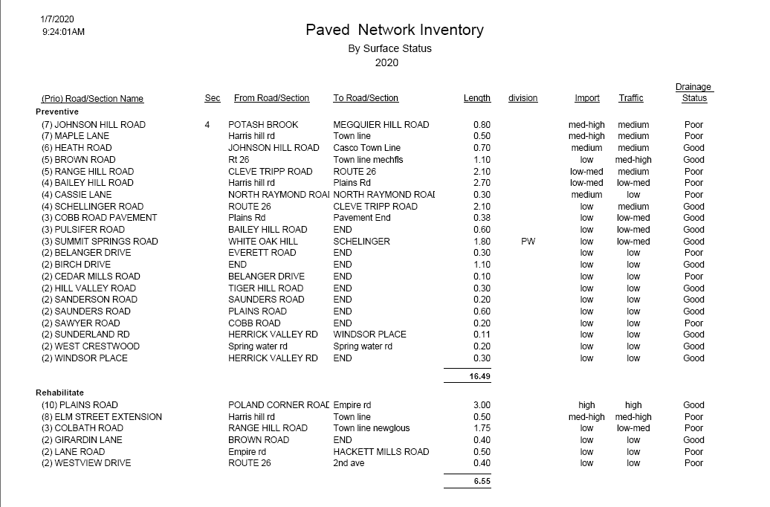
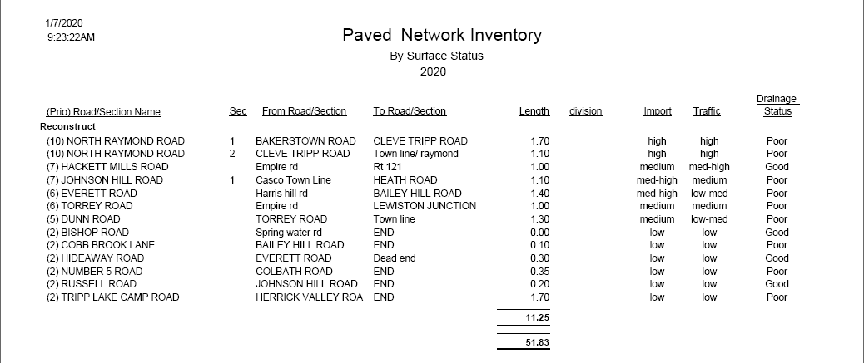

The following tables shows the RSMS Road Importance Analysis for public roads in Poland:
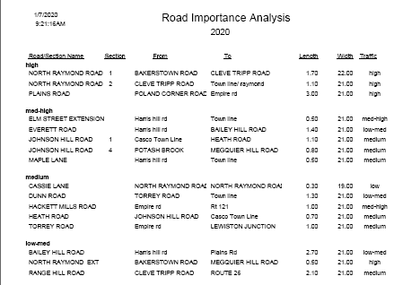

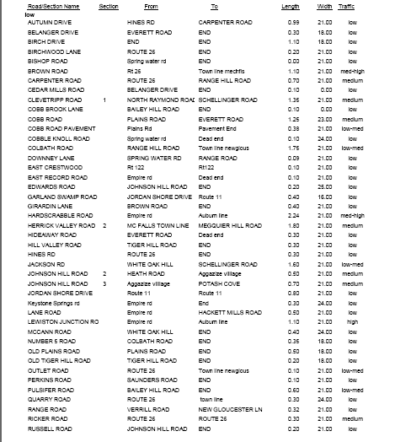

Highway/Road Capacities
MaineDOT maintains traffic volume data for selected roads in Poland. Typically, these counts are done every three years. However, data may not be available at all locations every three years because data collection points can change over time.

Location | 2007 | 2010 | 2011 | 2012 | 2013 | 2014 | 2017
Hackett Mill Rd south of Route 11/121 | 1840 | 1550 | --- | --- | --- | 1790 | 1750
Plains Rd northwest of Bailey Hill Rd | 2230 | 2010 | --- | --- | --- | --- | 2350
Empire Rd north of Route 122 | 890 | --- | --- | --- | --- | 930 | 940
White Oak Hill Rd east of Route 11 | 1230 | 1230 | --- | --- | --- | 1350 | 1260
White Oak Hill Rd south of Route 26 | 1390 | --- | --- | --- | --- | 1440 | ---
North Raymond Rd northwest of Route 11 | 850 | 950 | --- | --- | --- | --- | 720
North Raymond Rd southeast of Route 11 | 1030 | --- | --- | --- | --- | 1180 | 1230
Megquier Hill Rd west of Route 11 | 1140 | --- | --- | --- | --- | --- | 770
Plains Rd southeast of Poland Corner Rd | 2350 | 2100 | --- | --- | --- | --- | 2380
Carpenter Rd southwest of Route 26 | 1280 | 1620 | --- | --- | --- | 1310 | 1390
Route 11 southwest of North Raymond Rd | 3370 | 3360 | --- | --- | --- | 3410 | ---
Route 11 southwest of Megquier Hill Rd | 3210 | 3710 | --- | --- | --- | 3500 | 3710
Route 11 southwest of Winterbrook Rd | --- | --- | --- | 3270 | --- | 3060 | 3560
Route 11/121 west of Hackett Mill Rd | 9310 | 9600 | 9210 | --- | --- | 8910 | ---
Route 122 northeast of Route 26 | 5390 | 5060 | --- | --- | --- | 4400 | 5660
Route 122 northeast of Crestwood Rd (easterly junction) | 4770 | 4420 | --- | --- | --- | 3840 | 5150
Route 26 southeast of Route 11 | 7680 | 7050 | --- | 9690 | --- | 8670 | 9620
Route 26 south of Quarry Rd @New Gloucester townline | 6600 | 5930 | --- | --- | 7290 | --- | 8310
Route 26 south of Route 122 | --- | 6010 | --- | --- | --- | --- | 8390
Route 26 northwest of White Oak Hill Rd | 9430 | --- | --- | --- | --- | --- | 10630
Route 26 southeast of White Oak Hill Rd | 10500 | --- | --- | --- | --- | --- | 11730

Bridges
There are eight publicly owned bridges in Poland. Three of these bridges are owned and maintained by the town: Potash Bridge, Range Pond Bridge, and Adams Bridge. Eight of these bridges are owned by the state and maintained by MaineDOT: Manley Burnham, Lower Range Outlet Bridge, Middle Range Bridge, Minot Corner Bridge, and Hackett Mills Bridge.

The bridge inventory and classification system of public bridges in Poland has been established by MaineDOT. The following information has been provided by MaineDOT:

Poland Bridge Classification and Inventory
BRIDGE NAME | OWNER | YEAR BUILT | STRUCTURE LENGTH | DECK CONDITION | SUPERSTRUCTURE CONDITION | SUBSTRUCTURE CONDITION | CULVERT CONDITION | DATE OF INSPECTION
Potash | Town | 2003 | 18 feet | N/A | N/A | N/A | No noticeable or noteworthy deficiencies | 6/22/17
Manley Burnham | State | 1984 | 13 feet | N/A | N/A | N/A | No noticeable or noteworthy deficiencies | 11/21/17
Lower Range Outlet | State | 1938 | 15 feet | Satisfactory | Satisfactory | Good | N/A | 6/8/18
Minot Corner | State | 1956 | 147 feet | Satisfactory | Satisfactory | Good | N/A | 7/29/19
Middle Range | State | 2010 | 42 feet | Very Good | Very Good | Very Good | N/A | 10/4/18
Hackett Mills | State | 1932 | 122 feet | Very Good | Very Good | Satisfactory | N/A | 7/29/19
Range Pond | Town | 1950 | 23 feet | Very Good | Very Good | Fair | N/A | 6/22/17
Adams | Town | 2013 | 24 feet | Very Good | Very Good | Very Good | N/A | 5/7/19

MaineDOT defines the Federal Sufficiency Rating of a bridge as “a numeric indicator of the overall value of the sufficiency of the bridge. A rating will be from 0 to 100 (100=best, 0=worst). Federal Sufficiency Rating is computed with a federally supplied formula using an array of condition and inventory data. The formula is used to identify bridges eligible for federal funding. Federal sufficiency rating includes both structural deficiencies as well as functional obsolescence. This rating gives an overall value of the sufficiency of the bridge. Since functional obsolescence (too narrow or low weight capacity) may account for a large portion of the rating, do not assume that a low sufficiency rating means the bridge could “fail”.

Poland Bridge Sufficiency Rating
Bridge Name | Year Built | Federal Sufficiency Rating
Potash | 2003 | 97
Manley Burnham | 1984 | 63
Lower Range Outlet | 1938 | 62
Minot Corner | 1956 | 79
Middle Range | 2010 | 64
Hackett Mills | 1932 | 67
Range Pond | 1950 | 72
Adams | 2013 | 84

The MaineDOT posts bridges that are in need of improvement. Posting typically involves establishment of maximum weight limitations that can affect truck routing. None of the public bridges in Poland have been posted with any restrictions.

Crash Data
The Maine Department of Transportation (MDOT) maintains records of all reportable crashes involving at least $1,000 damage or personal injury. A report entitled “Maine Accident Report Summary” provides information relating to the location and nature of motor vehicle crashes. One element of the summary report is the identification of “Critical Rate Factor” (CRF), which is a statistical comparison to similar locations in the state. Locations with CRFs of 1.0 or greater and with more than eight crashes within a three-year period are classified as “High Crash Locations” (HCLs).

Based upon information provided by MaineDOT for the period January 1, 2016 to December 31, 2018, there were four HCL in Poland with a CRF greater than 1.00 and eight or more crashes.

Poland High Crash Locations – 2016-2018
Location | Total | Injury Crashes |  |  |  |  | Percent Injury | CRF | Ranking
 | Crashes | K | A | B | C | PD |  |  | State | County
Intersection of Route 11 & North Raymond Rd | 8 | 0 | 0 | 2 | 2 | 4 | 50.0% | 3.43 | 74 | 14
Intersection of Route 26, Route 122 and Carpenter Rd | 22 | 0 | 0 | 4 | 3 | 15 | 31.8% | 5.03 | 28 | 3
Intersection of Route 26 & Aggregate Rd | 8 | 0 | 0 | 0 | 3 | 5 | 37.5% | 1.86 | 186 | 36
Harris Hill Rd between Bailey Hill Rd & Everett Rd | 10 | 0 | 0 | 2 | 3 | 5 | 50.0% | 1.98 | 112 | 10

The intersection of Route 11, Route 26 and Winterbrook Road (a.k.a. Five Corners) was a HCL for decades, however after substantial investment to relocate Winterbrook Road south of the intersection and install a fully actuated traffic signal this is no longer a HCL.

Overall, there were 100 crashes in Poland in 2019. The following series of charts show details of those crashes according to a variety of characteristics (e.g. month/day of week, weather conditions, injuries, driver behaviors, etc.). The data source for these charts is MaineDOT.

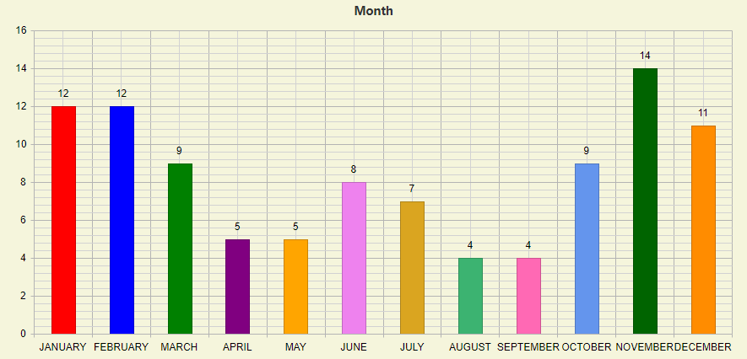
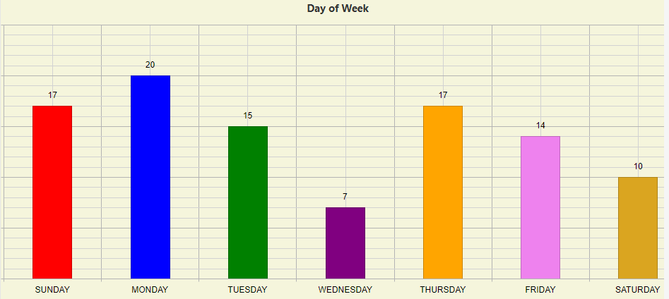
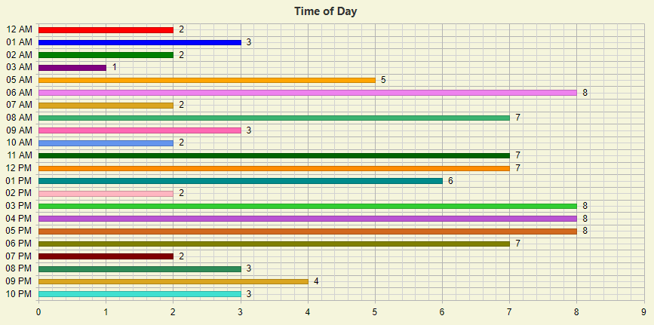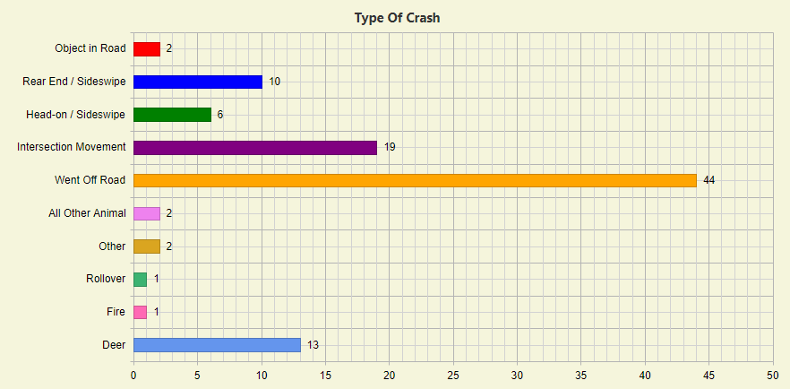

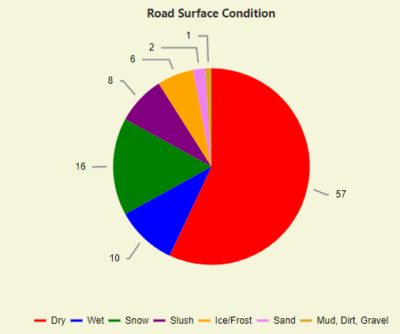

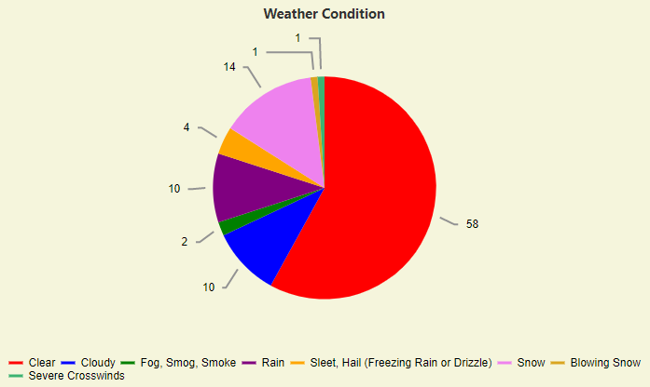

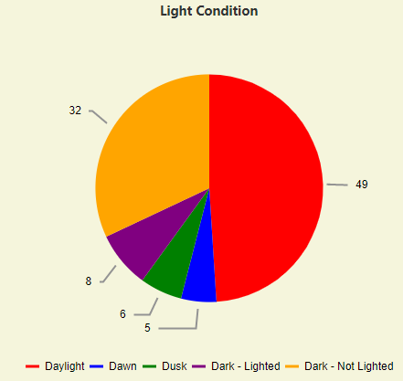

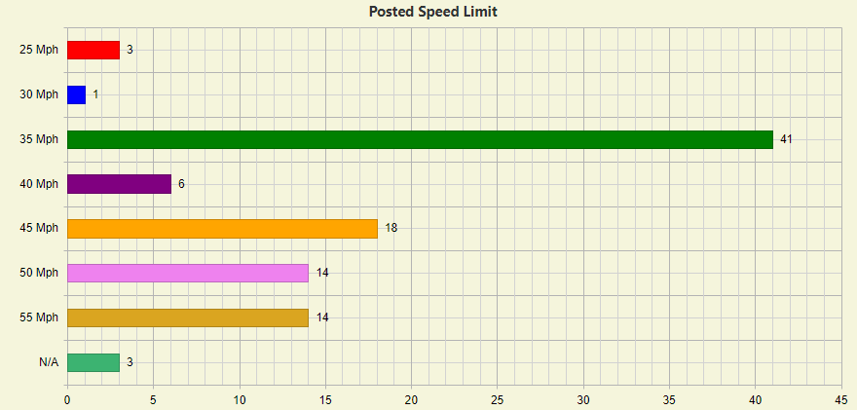
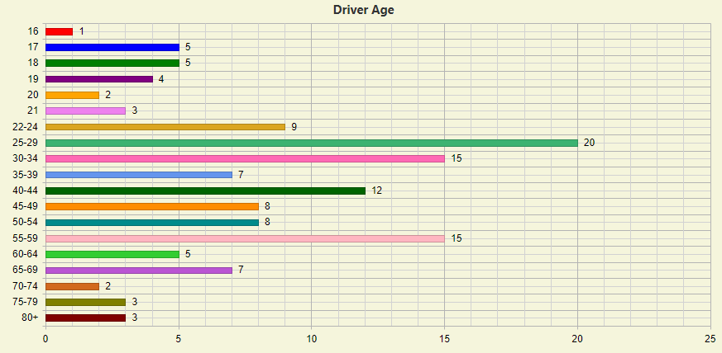 Note: Counts include all operators involved

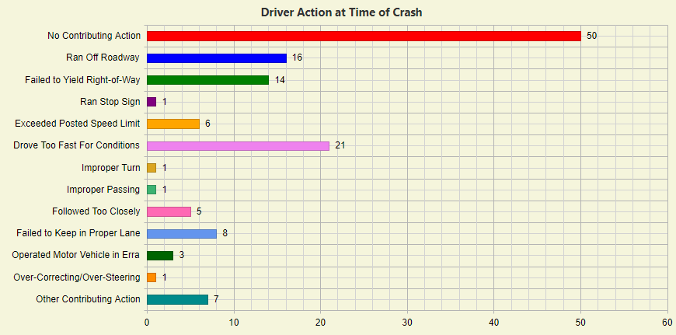
Note: Counts include all operators involved

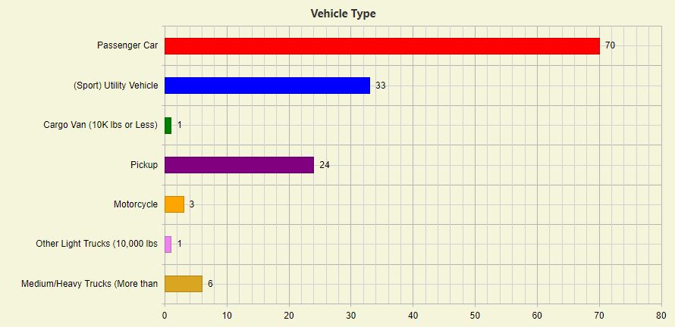
Note: Counts all vehicles involved
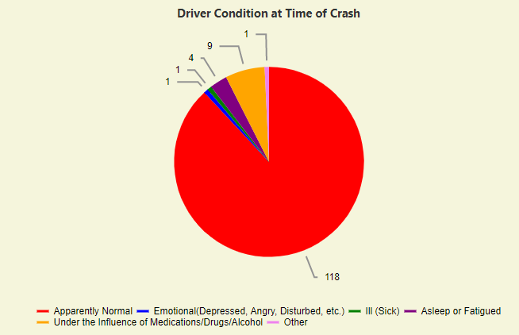
Note: Counts include all operators involved

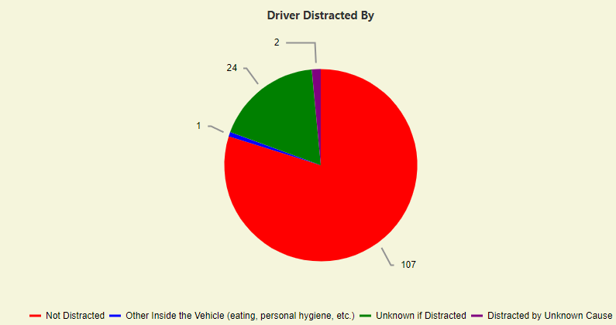
Note: Counts include all operators involved

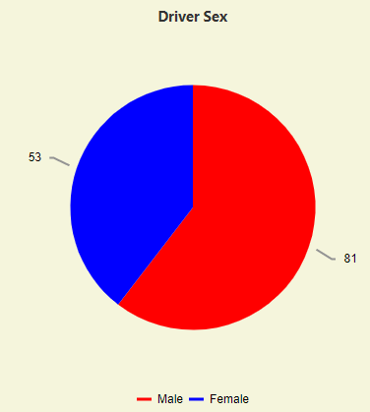
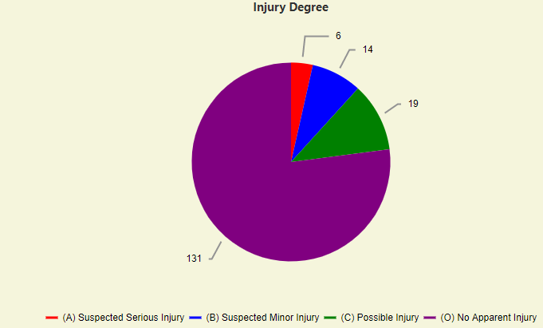
Note: Counts all individuals involved

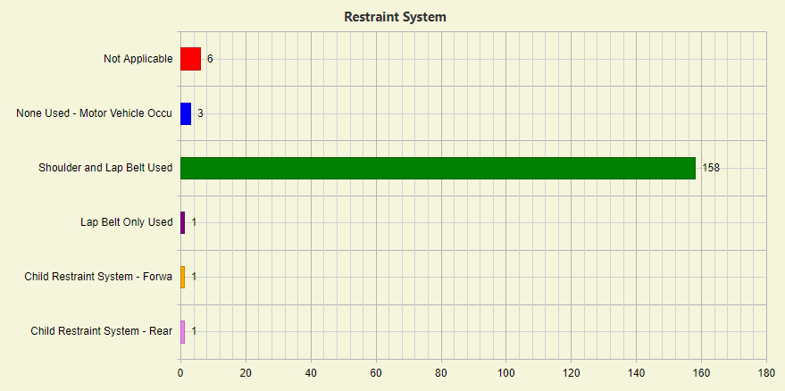
Note: Counts all individuals involved

Other safety issues of concern to the town include the traveling speeds on Route 26 at the Megquier Hill Road and North Raymond Road intersections and conflicts between motor vehicles and off-road vehicles on this section of Route 26, and conflicts at the intersection of Route 26 with Route 122 and Carpenter Road. The town has added safety signs and pavement markings at the Route 26/Megquier Hill Road and Route 26/North Raymond Road intersections and continues to monitor conditions. The MaineDOT will be investing in improvements to the Route 26/Route 122/Carpenter Road intersection to address known safety issues here, however this project has not been scheduled yet.

Access Management
In 2000, the Maine legislature adopted LD 2550, An Act to Ensure Cost Effective & Safe Highways in Maine. The purpose of this act is to assure the safety of the traveling public, protect highways against negative impacts on highway drainage systems, preserve mobility and productivity, and avoid long-term costs associated with constructing new highway capacity. The act is intended to conserve state highway investment, enhance productivity, manage highway capacity, maintain rural arterial speed, promote safety and conserve air, water and land resources.

The rules established as a result of this Act, apply to new or modified curb openings (driveways and entrances) on rural state and state-aid highways which have 5,000 average annual daily traffic (AADT) for at least 50% of its length. The standards regulate corner clearances, drainage, driveway spacing, driveway widths, parking, shared driveways and sight distance. The rules define certain arterial highways according to such characteristics as posted speeds, traffic volume, crash rates, etc.

A “Mobility Arterial” is defined as a non-urban compact arterial that has a posted speed limit of 40 m.p.h. or more and is part of an arterial corridor located between urban compact areas or “service centers” that has 5,000 average annual daily traffic for at least 50% of its length. Route 11 and Route 26 in Poland have been designated as Mobility Arterials.

A “Retrograde Arterials” are mobility arterials where the access-related crash-per-mile rate exceeds the 1999 statewide average for arterials of the same posted speed limit. In addition to meeting the standards for Mobility Arterials, mitigation measures are supposed to be required along Retrograde Arterials before new curb openings are be permitted by MaineDOT. Portions of Route 11 and Route 26 in Poland have been designated as Retrograde Arterials.

The rule has been amended numerous times by the Maine legislature since its original adoption and may not be as effective as originally intended. To ensure that mobility (timely flow of traffic) is maintained on Poland’s roads, the town should consider adopting the state’s access management rules without allowing the breadth of waivers currently available by the state.

Park & Ride Facilities
The town has a designated an area for vehicle parking at the town office to encourage commuters to share rides to work locations.

There are no MaineDOT Park & Ride facilities in Poland. The closest MaineDOT Park & Ride lot is located in downtown Mechanic Falls. Other MaineDOT Park and Ride facilities in the area include; Auburn I-95 Exit 75, near Turnpike entrance US 202 (this facility is co-located with a commercial bus service), Gray I-95 Exit 63, RT 202, and New Gloucester, Sabbathday Rd.

The MaineDOT Park & Ride Program is designed to encourage commuter ridesharing across the state. Due to a number of factors, the following rules went into effect in November 2015:

- Trailers, or any vehicles longer than 24 feet, are prohibited in MaineDOT Park & Ride Lots;
- Parking for more than seven days is never allowed; and
- During snow season, November 1– April 30, users cannot leave their vehicles for more than 24 hours. MaineDOT must be able to clear and sand the lots for commuters and this cannot be accomplished if vehicles are parked for more than 24 hours.

Sidewalks
Poland maintains approximately 2.1 miles of sidewalks along Maine Street, between the Five Corners intersection of Routes 11 and 26 at the Mechanic Falls townline and White Oak Hill Road, and approximately 0.2 miles of sidewalk on Ricker Road. Poland’s crosswalks are in Good condition. There are 7 crosswalks in Poland. Most of the crosswalks in Poland are located at Five Corners. There are four crosswalks on Maine Street between the Poland Regional High School baseball/softball fields and White Oak Hill Road.

In 2018 and 2019, MaineDOT contracted with AVCOG to analyze each crosswalk in AVCOG’s three county region, including those in Poland, to determine the degree of compliance with the Americans With Disabilities Act (ADA). Five of the fourteen curb ramps in Poland were found to be in compliance with the ADA. Four of the compliant curb ramps are on Bakerstown Road at Five Corners and the fifth compliant curb ramp is at the newest crosswalk on Maine Street across from the Poland Regional High School baseball/softball fields. The MaineDOT will be working to upgrade all non-compliant crosswalks, however, the implementation schedule has not been completed so there is no timeframe yet in which any of the non-compliant crosswalks will be brought into compliance.

Multimodal Routes
Off-road, multimodal routes provide alternative ways to travel through, and within, town. While these routes are sometimes considered to be for recreational use, they can be vital transportation corridors. The town of Poland is fortunate to have hard-working volunteers who have the desire to work with municipal officials and neighboring communities to develop not only local trails but trails that provide connections to the broader regional networks.

According to www.MaineTrailFinder.com, there are six trails networks in Poland, providing approximately 17 miles of off-road opportunities for the public. They are the Railroad Trail (connects Poland Community School to several recreation fields and the old railroad bed) the Heart of Poland Conservation Area Trails (a wooded network from Tripp Lake Road to the public library), Poland Spring Preservation Park (at Poland Spring Resort), Range Pond State Park trails, Range Pond State Park mountain bike trails, and the Bragdon Hill Conservation Area (a newly developed hiking trail that traverses a stream and continues to Bragdon Hill). There are no other dedicated bicycle routes or trails in Poland.

Additionally, there are approximately 43 miles of snowmobile trails in Poland that connect to the regional ITS network as well as to adjacent municipal snowmobile trails. The development of ATV trails in Poland is on-going and to date there is ATV access from Five Corners to Brown Road, access along the old railroad bed, and access from White Oak Hill Road to Schillenger Road.
Transit
Public transportation in rural areas is an increasingly necessary but inherently expensive service for local (county or municipal) governments to provide. Recent data indicates younger people are either unable to afford, or don’t want to own, a personal vehicle. There are a significant number of adults who have no personal transportation or license to operate a vehicle. Additionally, seniors want to remain engaged, but do not want to drive or have surrendered their licenses.

Western Maine Transportation Services (WMTS) is the designated regional transit provider for Androscoggin County. WMTS provides “demand-response” curb-to-curb and “flex-route” hybrid scheduled/off-route curb-to-curb, transportation services to residents of Androscoggin, Franklin and Oxford Counties. WMTS also provides commuter services in some areas. Buses and vans operated by WMTS are open to the general public.

Riders may use services provided by WMTS mostly as they would a personal vehicle, with the exception of limitations on the size, number and type of parcels allowed, and pets/animals being limited to small animals in carriers or trained service animals under control of the rider.

The greatest number of rides provided by WMTS are to healthcare appointments followed by shopping, personal appointments (hair, banking, social service, legal, etc.), employment, higher education, entertainment, social and family engagements, and dining at restaurants and senior meal centers, during non-holiday weekdays.

Since 2013, the rural transit environment has changed significantly with the MaineCare Non-Emergency Medical Transportation (NEMT) brokerage. The brokerage has disrupted service coordination and funding (both loss of direct service reimbursements and loss of the associated local match). Establishing the brokerage cost the state roughly 2/3 of its volunteer driver base and caused a loss in capacity and efficiency estimated, in some cases, to be between 20% and 25%, due to performance metrics which were imposed on transportation providers carrying MaineCare clients.

WMTS presently serves Poland one day a week along with Mechanic Falls. WMTS will consider adding more service if demand and/or ridership supports it. WMTS met with the Poland Economic Development Committee (EDC) in October of 2019. It was noted there are likely people in Poland who would travel to Hannaford in Mechanic Falls and other locations, as well as to Auburn and Lewiston if the service could be provided. The decentralized nature of the town was acknowledged by the EDC and conducting a survey was discussed. WMTS looks forward to resuming that conversation.

The numbers below are rides originating in Poland that were provided by WMTS. The ridership data listed after 2013 was from the area of town nearest Auburn.

BUS RIDERSHIP OF POLAND RESIDENTS
2012 | 2013 | 2014 | 2015 | 2016 | 2017 | 2018 | 2019
189 | 39 | 0 | 3 | 0 | 2 | 12 | 1
Source: Western Maine Transportation Services, Inc.

The number of trips provided and demonstrated in the table above may not appropriately reflect the need or desire for rural public transportation in Poland. Prior to the COVID-19 pandemic, WMTS was beginning to explore how to serve smaller outlying towns with scheduled weekly or monthly service to regional service centers.

In April 2019, WMTS initiated the GreenLine Commuter Service, a daily commuter route between Farmington and Lewiston-Auburn with five trips per weekday. In the summer of 2019, MaineDOT opened a park & ride lot at Brettun’s Variety on Route 4 in Livermore. Brettun’s Variety is a bus stop on the GreenLine Commuter Service that is mid-way between Farmington and Lewiston-Auburn. The GreenLine bus offers free on-board Wi-Fi, a bike rack in-season, and takes credit, debit and WMTS SmartCommute cards, as well as Apple, Samsung and Android Pay mobile apps for payment. Exact change is also accepted.

In November 2019, WMTS initiated a new weekday service serving the River Valley region. The GreenLine Connection is a connector commuter route between Rumford and Brettun’s Variety in Livermore, with stops in Mexico, Dixfield, Peru and Canton. This service has not been widely promoted because it is still in its pilot phase of development.

Other transportation services provided in the region include a few for-profit taxi and van operators which are utilized by LogistiCare, a non-emergency medical transportation broker. Commercial taxi operators providing general transportation, as opposed to those providing MaineCare rides, are not consistently available in most towns. Community Concepts, Inc. provides contract and grant-based transportation, mostly to clinical appointments along with some MaineCare transportation. None of these providers are considered to be “public transit” providers.

Currently, ridesharing/ride-hailing (Uber, Lyft, etc.) services are, if available at all in rural areas of the state, generally, not reliable due to hours of availability and numbers of drivers who sign-up. This is mostly due to the business model requiring a minimum population density greater than what typically exists in Western Maine communities in order to be profitable and sustainable for drivers.

While there are community-based volunteer driver networks in some towns, they are not widespread. Community volunteer driving programs are not easy to start and can be difficult to maintain due mostly to the availability of drivers and possible liability exposure for drivers and sponsor organizations.

Even with the available transportation options, the transportation needs of residents may not be able to be met without additional public or other transit services.

Rail
The St. Lawrence & Atlantic Rail (SLR) bisects Poland and is an active freight line.

In 2014, a $3.0 million reconstruction project of the former Rangeley Branch rail line was completed. The project consisted of restoring approximately 6,600 linear feet of the former Rangeley Branch rail line while also adding approximately 400 linear feet of new track for a spur line leading from the midpoint of the mainline to an abutting commercial property, and an additional 1,500 linear foot double-ended siding for increased capacity. The project provides additional rail access to land zoned for commercial and industrial development in Auburn and Poland while alleviating congestion on the existing SLR line serviced through the intermodal transportation facility on Lewiston Junction Road in Auburn. Although the intermodal facility is not operating currently, the construction project represents new economic development opportunities for business growth in Poland.

There are two at-grade rail crossings in Poland on Empire Road and Hackett Mills Road. There are no known safety concerns at either of these rail crossings.

In September 2013, the town of Poland adopted a Resolution endorsing the Androscoggin, Oxford & Coos Counties Corridor Coalition, which was formed by municipalities in Androscoggin and Oxford Counties and Coos County in New Hampshire for the purpose of identifying, exploring and implementing opportunities for regional collaboration in restoration of passenger rail for economic development. The Coalition’s focus is the reestablishment of passenger rail service between Montreal and Boston via the St. Lawrence & Atlantic Rail line in Western Maine. Poland staff remains active in participating in this coalition.

Aviation
There are no public airports in Poland. The Lewiston/Auburn Municipal Airport approximately 6 miles away in Auburn. The Oxford County Regional Airport is located approximately 8 miles away in Oxford.

Regional Transportation Plans
The 2015 Androscoggin Valley Council of Governments Regional Strategic Transportation Investments Plan has identified the following projects which could provide opportunities for Poland:

- Upgrade Route 26 to current federal construction standards,
- Extend intercity passenger rail service from Portland to Montreal with stops in Auburn, Oxford Hills and Bethel.
- Connect local trail networks to regional systems
- Provide bicycle-pedestrian infrastructure and facilities, where appropriate, as roads are upgraded

MaineDOT Plans
The MaineDOT maintains several transportation plans including the Statewide Long-Range Transportation Plan, the Statewide Transportation Improvement Program and the capital/maintenance Work Plan.

The Long-Range Transportation Plan is a 20-year policy-based transportation plan. The Plan identifies MaineDOT's vision for the future and provides guidance and insight on the necessary strategies to meet the state’s transportation goals over the next 20-30 years. MaineDOT has identified 8 key trends that are anticipated to impact transportation in the years ahead: Maine's aging population, labor market/industry, global trade/freight movement, urbanization/shifting population, tourism, technology, safety, and climate.

The Statewide Transportation Improvement Program (STIP) is a four year, federally required, transportation capital improvement program. The STIP identifies federal funding by year for scheduled transportation projects that may be receiving FHWA or FTA funding. MaineDOT produces a STIP to meet the following principal requirements: the State of Maine must show fiscal constraint by not scheduling more transportation projects for construction, per year, than it can reasonably expect to receive in funding, to certify that the State’s transportation program conforms to Federal air quality regulations, and to provide all interested parties a reasonable opportunity to comment on the proposed STIP. The STIP includes capital projects identified in MaineDOT’s three year Work Plan. The 2020-2023 STIP identifies only one capital projects in Poland:

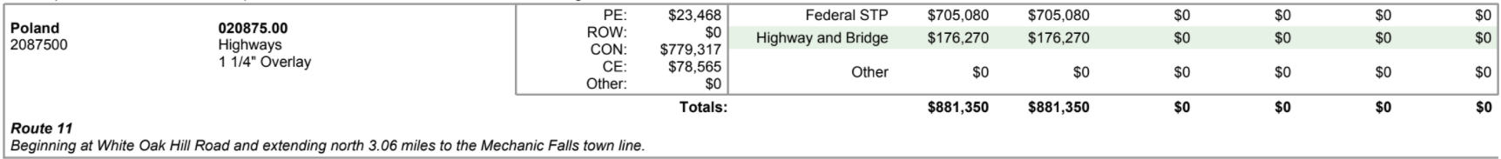

The Work Plan identifies capital and maintenance projects to be worked on over the next three calendar years, beginning with the present year. This Plan is updated annually by MaineDOT. The majority of the capital projects listed in the Work Plan are eligible for FHWA and FTA funding. The MaineDOT 2020-202 Work Plan identifies the following project in Poland:

Project ID Number | Year | Road/Subject | Length | Project Description
023707.00 | 2020/21 | Route 11 | 0.17 miles | Highway Safety & Spot Improvements-Slope Stabilization/Protection

GOALS, POLICIES & ACTION STRATEGIES

Introduction

State goals that need to be addressed

Town’s Goals/Policies/Strategies

